**Time:** 3Hours **Marks:** 40

**Consider the following ERD**

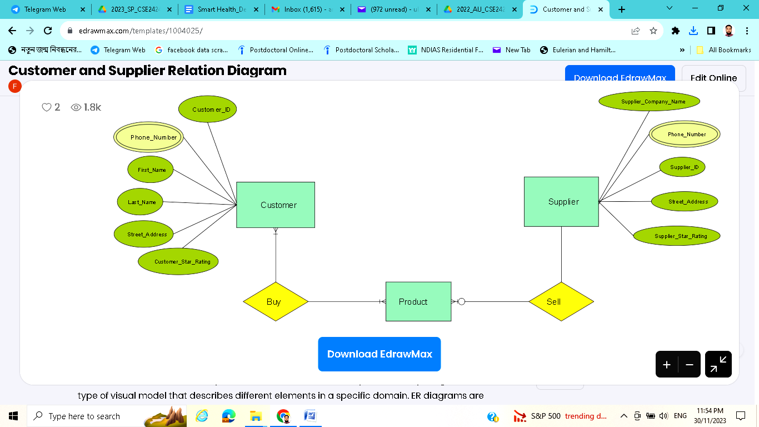

| **REQUIREMENTS:** |  | **CO** | **DL** |
| --- | --- | --- | --- |
| 1. Create a user as DBA with your **matric number** and implement following in it. | **2.5** | **CO1** | **C3** |
| 1. Create the necessary relations including all the possible constraints and additional attributes if needed (write the DDL statement in the answer script) | **10** | **CO2** | **C3** |
| 1. Input at least five data records in each of the newly created relations (no need to write in the answer script) 2. **Write DML statements on following** (write the DML statement in the answer script (***any three***))**:** | **2.5** | **CO1** | **C2** |
| 1. Crate a view that includes supplier name of order number ‘Or01’ and Write a PL/SQL code that shows information from that view. 2. Write a PL/SQL code to show the product details that have sold more than 20000. 3. Write a PL/SQL code to show the list of customers who have have ordered same product as ‘Ahnaf’ 4. Write a SQL code to show the total amount for each customer for the month November 2023 | **5*3=15** | **CO1** | **C4** |
| 1. Create a DB with your name in MongoDB and create a collection with your matric number in that DB. Insert at least five documents in your collections regarding customers and products. Finally, do the following   a) Find the name of the customers whose status is neither active nor neutral  b) Find the details of  product of unit price range 50-500 | **2+2+2+4 =10** | **CO1** | **C3, C4** |